Template
Software Design Specification
Version 1.0

Revisions
Version | Primary Author(s) | Description of Version | Date Completed
Contents
1 Introduction 1
1.1 System Overview 1
1.2 Supporting Materials 1
1.3 Definitions and Acronyms 1
2 Design Considerations 2
2.1 Assumptions 2
2.2 Constraints 2
2.3 Goals and Guidelines 2
3 Architecture 3
3.1 Overview 3
3.2 Strategies 3
3.2.1 Technical Environment 3
3.2.2 Maintainability 3
3.2.3 Performance 3
3.3 Software Specification 3
3.4 Hardware Specification 3
4 System Level Design 5
4.1 Hierarchy Chart Of Components 5
4.2 Sequence Diagrams And Descriptions 5
5 Object Level Design 6
5.1 Component C1 6
5.1.1 Class D1 Of Component C1 6
5.2 Component C2 6
6 User Interface Design 7
6.1 User Interface Design Overview 7
6.2 User Interface Navigation Hierarchy 7
7 Requirements Traceability Matrix 8
8 Appendices 9

Introduction
<Provide an overview of the entire document, including the purpose, the scope and the intended audience of the document. Identify the product using any applicable names and/or version numbers.>

System Overview

<Provide a general description of the software product including its functionality and matters related to the overall system and its design.>

Supporting Materials
<Provide references for any other pertinent documents such as related and/or companion documents, prerequisite documents and documents which provide background and/or context for this document.>

Definitions and Acronyms
<Define any important terms, acronyms, or abbreviations.>
Term | Description
UCO | University of Central Oklahoma
iOS | Internetwork Operating System
GSM | Global System for Mobile
SMS | Short Message Service
IIS | Internet Information Services

Design Considerations

Assumptions
<Describe any assumptions or dependencies regarding the software and its use. These may concern such issues as related software or hardware, operating systems, end-user characteristics, and possible and/or probable changes in functionality.>
Our software depends on the performance of the server, internet connection, and user device in order to be operational. The software shall operate on the assumption that the server and UCO WIFI are operational. The server must be able to support the volume of users, which could increase the longer the software is available to the UCO community. The UCO WIFI or user device 3G or 4G capability will also be a dependency that the software will depend upon in order to be functional. In addition, the software operates with the assumption that UCO has parking lots that have handicapped parking spaces. If for whatever reason these were removed, the software would not be usable. The software shall operate under the assumption that UCO is still an operating institution, since the software genesis occurred to serve UCO faculty, staff, and students. This software operates on the assumption that only handicapped UCO faculty, staff, and students will park in the handicapped parking spaces. Individuals have only one account, so only one reservation will be made at any one time by a user. This software is designed under the assumption that mini-browsers are usable by Android, iOS, and desktop computers.

Constraints
<Describe any global limitations or constraints that have a significant impact on the design of the system's software. Such constraints may be imposed by any of the following (the list is not exhaustive): hardware or software environment, end-user environment, availability or volatility of resources, standards compliance, interoperability requirements, interface/protocol requirements, data repository and distribution requirements, security requirements (or other such regulations), memory and other capacity limitations, performance requirements, network communications, and other requirements described in the requirements specification.>
The software’s usefulness is directly tied to user input, which means that the user is the ultimate constraint on the software. Although all parking reservations are cleared and all parking spots are marked open at midnight every day, the users help maintain the accuracy of the system during the hours in which the system would be most frequently utilized. The software is further constrained by the volume of user traffic that the server can handle. The software has the physical constraint of the number of handicapped parking spaces that are available in each lot. Although there are many parking lots on the UCO campus that have handicapped parking spaces, not all of these lots are present on the software. The user is constrained to reserving parking spots in the lot(s) that are in the database.

Goals and Guidelines
<Describe any goals, guidelines, principles, or priorities which dominate or embody the design of the system's software. Such goals might be: the KISS principle ("Keep it simple stupid!"), emphasis on speed versus memory use, or working, looking, or "feeling" like an existing product. For each such goal or guideline, unless it is implicitly obvious, describe the reason for its desirability.>
This software has three goals in mind; namely usability, scalability, and accuracy. First, the software must be easily utilized by the end-user or this software serves no purpose. This software needs to make parking for handicapped individuals more efficient and painless, not more difficult. Secondly, the software needs to be scalable, meaning that it could be expanded to multiple parking lots or even multiple campuses. Thirdly, this software needs to be accurate so that users are able to depend on the data in the system. With these goals in mind, this software shall be designed to serve the handicapped community at UCO.

Architecture

Overview
< Determine what parts of the application software will be assigned to what hardware. Describe any design decisions and/or strategies that affect the overall organization of the system and its higher-level structures. These strategies should provide insight into the key abstractions and mechanisms used in the system architecture. Describe the reasoning em-ployed for each decision and/or strategy (possibly referring to previously stated design goals and principles) and how any design goals or priorities were balanced or traded-off.>

Strategies

Technical Environment
<Special hardware, software, and network requirements imposed by business requirements>
Business requirements do not necessitate any special hardware or software beyond a GSM modem or SMS messaging service to facilitate timely reporting of reservation usage in the way of arrivals and departures. General system hardware and software needs are listed in sections 3.2.3 and 3.2.4.

Maintainability
<Expected business changes to which the system should be able to adapt>
In order to be maintainable, the system could be switched to a larger server. SMS might necessitate extra GSM modems. Any unforeseen connectivity or authentication issues shall be handled on a case-by-case basis.

Performance
<The time within which the system must perform its functions; the total and peak number of users and volume of data expected; the extent to which the system will be available to the users and the permissible failure rate due to errors>
Any request from the browser has to respond to the user within 100 seconds or it shall result in a time-out. The expected number of users is expected to be less than 1000. The system is expected to handle 10 MB per year.

Software Specification
<Determine software needs, such as OS, development IDE, JDK version, other SDK version, etc. >
The server shall be a Windows Server 2008 or later, which includes Internet Information Services (IIS) and .NET framework, 4.0 or later. The software shall be developed in Visual Studio, Web Storm (Jet Brains), and SQL Server Express.

Hardware Specification
- Clients
  - Mobile devices, desktop systems, laptops
- Servers
  - File/application server connected to the internet capable of running:
    - Data service (SQL Server)
    - Web service (IIS)
  - Accessible by many users
- Network
  - GSM modem or online service for sending SMS messages
  - SSL that will need to have a registered certificate (Verisign)

System Level Design
<Provide a high-level overview of how the functionality and responsibilities of the system were partitioned and then assigned to subsystems or components. Don't go into too much detail about the individual components themselves (there is a subsequent section for detailed component descriptions). The main purpose here is to gain a general understanding of how and why the system was decomposed, and how the individual parts work together to provide the desired functionality.>
Per the Software Requirements Specification (SRS), the Handicapped Driver design is required to “provide user/driver interaction via web browsers on both Android and iOS smart devices and Windows and OSx operating systems” (SRS 1.1); therefore, a presentation layer (GUI) was designed as an independent section and partitioned accordingly. Additionally, the system must store information related to parking lots/spaces, registered drivers and ongoing reservations made by drivers for the spaces. Therefore, an independent data layer (database) was also designed and partitioned. The core of the system remains as its own layer and contains both business logic and components to interact with the aforementioned presentation and data layers. The core also contains adapters as interfaces that implement features facilitated by external systems such as communication (SMS and Email), road navigation (Google Maps), and the scheduled “cleanup” of internal data. Overall, the Handicapped Driver System is architected as a multi-tier software solution within a web-based client-server paradigm.

Hierarchy Chart of Components
<Describe the major responsibilities that the software must undertake and the various roles that the system (or portions of the system) must play. Describe how the system was broken down into its components/subsystems (identifying each top-level component/subsystem and the roles/responsibilities assigned to it). Describe how the higher-level components collaborate with each other in order to achieve the required results. Don't forget to provide some sort of rationale for choosing this particular decomposition of the system (perhaps discussing other proposed decompositions and why they were rejected). >
As shown below (fig 4.1), the system is broken down by design into four major packages: data, presentation, core logic and external systems. The data layer contains the underlying storage implemented in normalized database form plus services that execute SQL instructions for data operations (select/insert/update/delete); this is a common software industry approach to data handling and utilizes Structured Query Language (SQL), another industry standard. The presentation layer is designed for execution within any browser that can render HTML and execute JavaScript. As both mobile devices (Android, iPhone) and desktop systems (Windows, iOS, Linux) employ such browsers, this approach provides a common “look and feel” for users and allows minimal code and GUI design duplication for developers. Access to features provided by external systems are handled by adapters used to implement inter-system operations transparently to the core system. Business logic for the reservations, as well as, the adapters, and a bridge to the data layer are all designed into the core system; a façade, or “focal point” for communication with the presentation layer components is additionally integrated into the system core. High-level system architecture was driven first by the requirement that user interaction was to occur via a multitude of disparate devices and operating systems, thus leading to the client-server model using a web browser client. Further divisions were made to separate the data access component for scalability (i.e. MS Access to Oracle), and to accommodate and group external system dependencies together. The result of multiple divisions is an overall multi-tiered architecture.

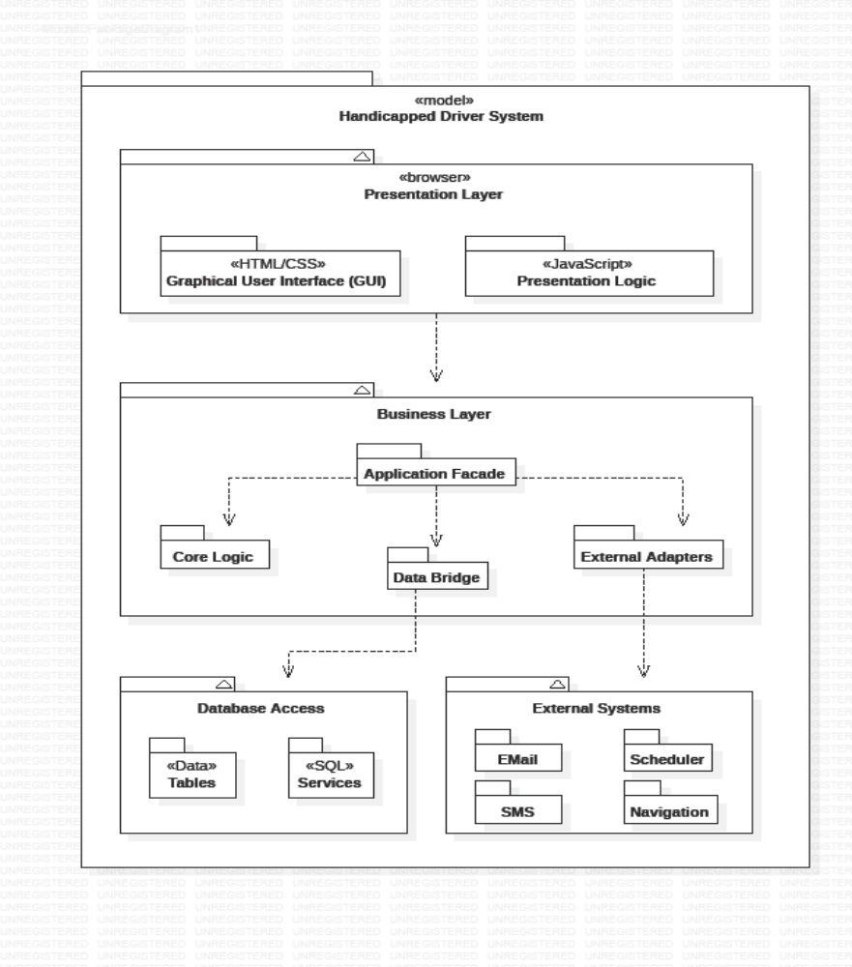
Figure 4.1 – Package Diagram

Sequence Diagrams and Descriptions
<Describe the interaction behavior between classes. The typical sequence diagram will depict some or all of the behavior described in a use case. Therefore, sequence diagrams serve as an intermediary between use cases and classes. As a result, classes can be traced back to the requirements. >
The system requires a simple login sequence before any interaction with the rest of the system is allowed (minus the New User feature). Depicted below is the initiation from the Login page within the GUI. The user’s login name and password are collected and passed to the Application Façade, through to the Driver class of the core system for any necessary pre-processing. The Driver class then verifies that the collected information matches that stored in the database by searching (through the Data Bridge) for a match. A success or failure token is then sent back through each initiating class until the user is either logged in or asked to “try again”.

Figure 4.2a – User/Driver Login

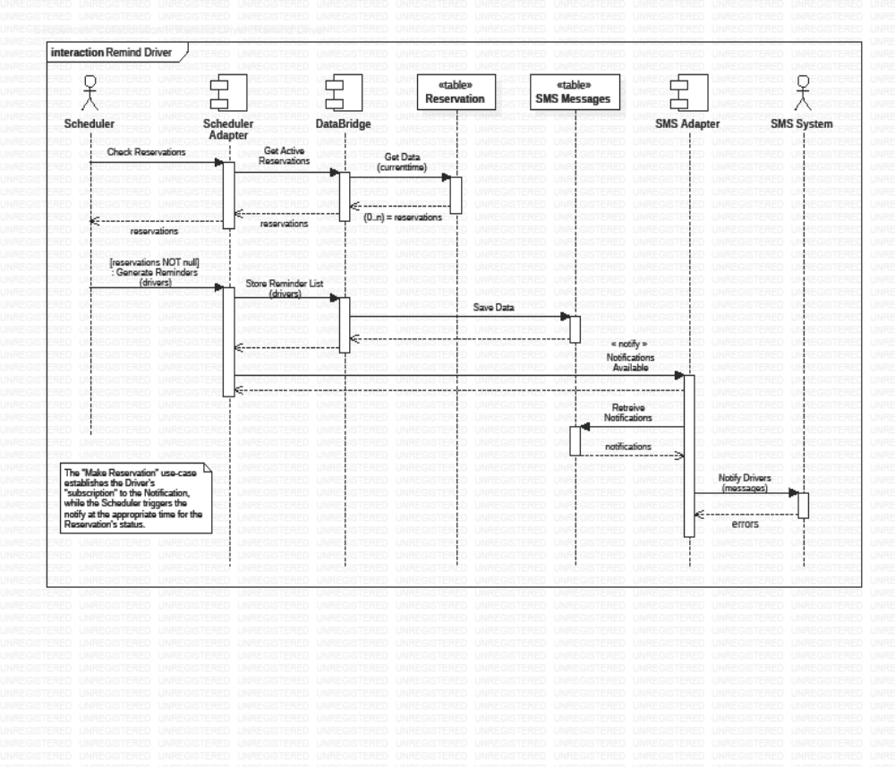
Figure 4.2b – Remind Driver

Figure 4.2c – Make Reservation

Figure 4.2d – Use Reservation (Park, Leave or Cancel)

Object Level Design
<Provide more detailed discussion in a subsection/component of the component hierarchy section 4.1. If necessary, describe how the component was further divided into subcomponents, and the relationships and interactions between the subcomponents (similar to what was done for top-level components in Section 4.1).>
Handicapped driver system is divided into four main levels according to the role. They are Presentation layer, Core system, External system and Database (see sec 4.1 package diagram).

GUI
<Provide and describe a class hierarchy diagram that depicts the set of classes for Compo-nent C1>

[Handicappeddriver system.Full.mdj]
The web pages consist of Images, HTML/CSS, and Script files. The classes represented on the left side of the web page are listed from the standard Document Object Model (DOM) for completeness.

GUI class diagram

Login page
Login
-user_name
-password
+Submit

<Provide a class diagram for Class D1 of Component C1. Provide a description of any relevant characteristics of Class D1.>
This class diagram represents Login page. This allows the user to securely login to their account.
user_name: - The user enters the his/her UCO username. (the user do not have to enter the UCO email extension).
password: - The user enters his/her password.
Submit: - The user clicks the submit button to login.

Home Page

Home page
+update_profile
+view_available
+my_reservation
+ message_driver

update_profile: - Update/Create user profile.
view_available: - This will let the user view currently available spaces.
my_reservation: - This would let the user view their current reservation.
message_driver: - This would let the user message other drivers.

Update profile
Update profile
-user_name
-uco_email
-phone_number
-vehicle_registration_number
-Password
-confirm_password
+Submit

user_name: - Here the user enters their user name
uco_email: - Here the user enters the UCO email address.
vehicle_registration_number: - Here the user enters his/her vehicle registration number.
phone_number: - Here the user enters their phone number for receiving notifications.
confirm_password: - Here the user confirms his/her password by re-typing the password.

View available
View available
Lots: dropdown

campus_map
reserve
campus_map: - Lets the user view the campus map.
reserve: - lets the user reserve a spot.

Show campus map
Show reservation
occupy: Status
leave: Status
cancel: Status
navigate
occupy, leave, cancel: - Let’s the user change the status of their spot accordingly.
navigate: - Navigate to reserved spot.

JavaScript libraries
This package is for script libraries that shall be determined during implementation phase.

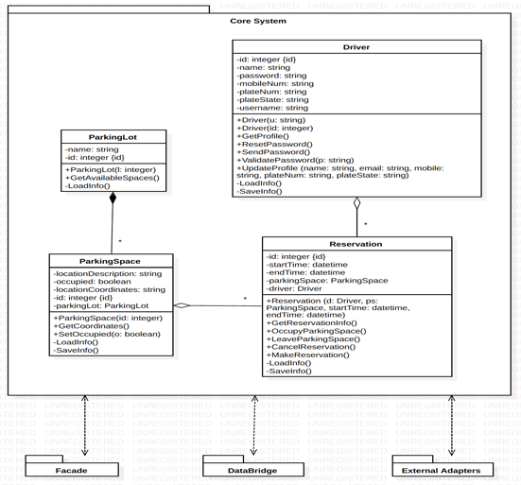
Core

The core system consists of the Driver, Reservation, ParkingSpace, and ParkingLot classes.

Driver Class Diagram
Driver
-id: integer {id}
-name: string
-password: string
-mobileNum: string
-plateNum: string
-plateState: string
-username: string
+Driver(u: string)
+Driver(id: integer)
+GetProfile()
+ResetPassword()
+SendPassword()
+ValidatePassword(p: string)
+UpdateProfile(name: string, email: string, mobileNum: string, plateNum: string, plateState: string)
+LoadInfo()
+SaveInfo()

id
name
password
mobileNum
plateNum
plateState
username
Driver(u: string)
Driver(id: integer)
GetProfile()
ResetPassword()
SendPassword()
ValidatePassword(p: string)
UpdateProfile(name: string, email: string, mobileNum: string, plateNum: string, plateState: string)
LoadInfo()
SaveInfo()

Reservation Class Diagram
Reservation
-id: integer {id}
-startTime: datetime
-endTime: datetime
-parkingSpace: ParkingSpace
-driver: Driver
+Reservation (d: Driver, ps: ParkingSpace, startTime: datetime, endTime: datetime)
+GetReservationInfo()
+OccupyParkingSpace()
+LeaveParkingSpace()
+CancelReservation()
+MakeReservation()
-LoadInfo()
-SaveInfo()

id: integer {id}
startTime: datetime
endTime: datetime
parkingSpace: ParkingSpace
driver: Driver
Reservation (d: Driver, ps: ParkingSpace, startTime: datetime, endTime: datetime)
GetReservationInfo()
OccupyParkingSpace()
LeaveParkingSpace()
CancelReservation()
MakeReservation()
LoadInfo()
SaveInfo()

ParkingSpace Class Diagram
ParkingSpace
-locationDescription: string
-occupied: boolean
-locationCoordinates: string
-id: integer {id}
-parkingLot: ParkingLot
+ParkingSpace(id: integer)
+GetCoordinates()
+SetOccupied(o: boolean)
-LoadInfo()
-SaveInfo()
locationDescription: string
occupied: boolean
locationCoordinates: string
id: integer {id}
parkingLot: ParkingLot
ParkingSpace(id: integer)
GetCoordinates()
SetOccupied(o: boolean)
LoadInfo()
SaveInfo()

ParkingLot Class Diagram
ParkingLot
-name: string
-id: integer (id)
+ParkingLot(i: integer)
+GetAvailableSpaces()
+LoadInfo()
name: string
id: integer (id)
ParkingLot(i: integer)
GetAvailableSpaces()
LoadInfo()

Façade

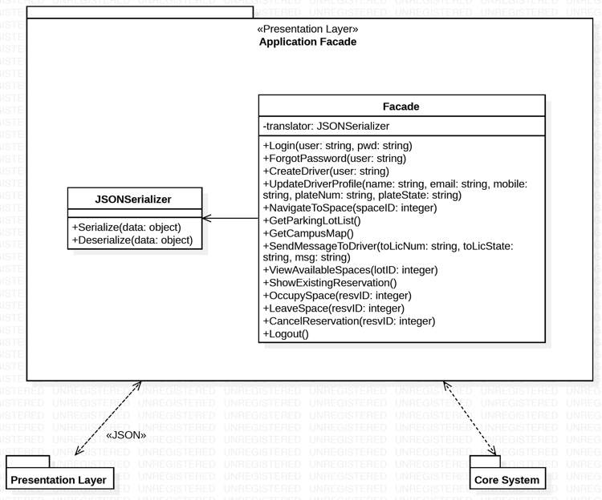
Something about the façade and how it works.

Façade Class Diagram
Façade
-translator: JSONSerializer
+Login(user: string, pwd: string)
+ForgotPassword(user: string)
+CreateDriver(user: string)
+UpdateDriverProfile(name: string, email: string, mobileNum: string, plateNum: string, plateState: string)
+NavigateToSpace(spaceID: integer)
+GetParkingLotList()
+GetCampusMap()
+SendMessageToDriver(toLicNum: string, toLicState: string, msg: string)
+ViewAvailableSpaces(lotID: integer)
+ShowExistingReservation()
+OccupySpace(resvID: integer)
+LeaveSpace(resvID: integer)
+CancelReservation(resvID: integer)
+Logout()

translator: JSONSerializer
Login(user: string, pwd: string)
ForgotPassword(user: string)
CreateDriver(user: string)
UpdateDriverProfile(name: string, email: string, mobileNum: string, plateNum: string, plateState: string)
NavigateToSpace(spaceID: integer)
GetParkingLotList()
GetCampusMap()
SendMessageToDriver(toLicNum: string, toLicState: string, msg: string)
ViewAvailableSpaces(lotID: integer)
ShowExistingReservation()
OccupySpace(resvID: integer)
LeaveSpace(resvID: integer)
CancelReservation(resvID: integer)
Logout()

JSONSerializer Class Diagram
Do I need this?

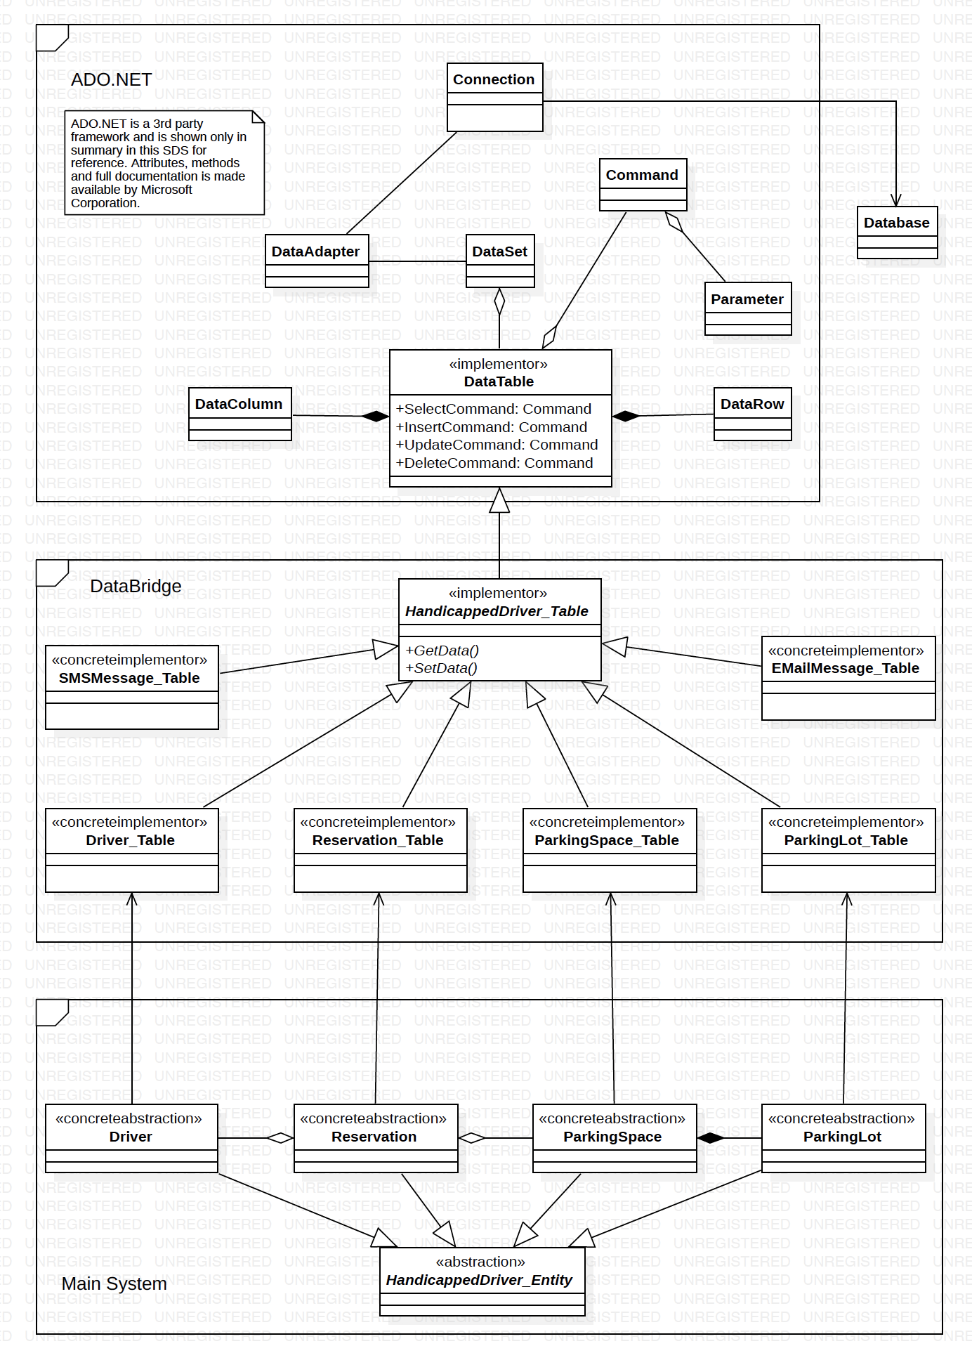
DataBridge

Write something about the bridge and what not.

HandicappedDriver_Table Class Diagram
HandicappedDriver_Table
+GetData()
+SetData()
GetData()
SetData()

SMSMessage_Table Class Diagram
SMSMessage_Table

Driver_Table Class Diagram
Driver_Table

Reservation_Table Class Diagram
Reservation_Table

ParkingSpace_Table Class Diagram
ParkingSpace_Table

ParkingLot_Table Class Diagram
ParkingLot_Table

EmailMessage_Table Class Diagram
EmailMessage_Table

Adapter

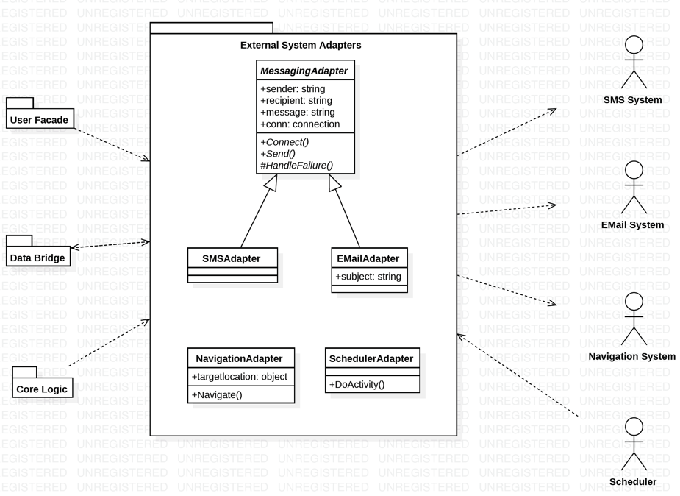
Write something about the adapter

Messaging_Adapter Class Diagram
Messaging_Adapter
+sender: string
+recipient: string
+message: string
+conn: connection
+Connect()
+Send()
#HandleFailure
sender: string
recipient: string
message: string
conn: connection
Connect()
Send()
#HandleFailure

SMSAdapter Class Diagram
SMSAdapter

EmailAdapter Class Diagram
EmailAdapter
+subject: string

subject: string

NavigationAdapter Class Diagram
NavigationAdapter
+targetlocation: object
+Navigate()
Targetlocation: object
Navigate

SchedulerAdapter Class Diagram
SchedulerAdapter
+DoActivity()

User Interface Design

User Interface Design Overview
<Provide a high-level description of the user interface for this software application. Describe any systems requirements (e.g., performance or usability) associated with all of the user interfaces. >
A client-server-based software must have a user interface. Therefore, it is one of the main elements in any software system. This system is no different. The presentation layer of the system utilizes HTML5/CSS3 as the GUI and JavaScript and as it’s presentation logic. The interface contains of a series of responsive pages that the user can interact. Initially, the user will be taken to a login screen where the user can enter their credentials to login. Once successfully logged in, the user will be directed to the home page/landing page where there are four options. Those options include: update user’s password, view available spaces, view their reservation, and message driver. Note that the purpose of message driver is that it will notify the driver who have taken a spot reserved for another driver. Also, to prevent aggressive communication between drivers, the system will automatically generate messages.
The interface will run on any web browsers which supports HTML5/CSS3. Depending on network speed, the web pages should load within the default time of a web requests.

User Interface Navigation Hierarchy
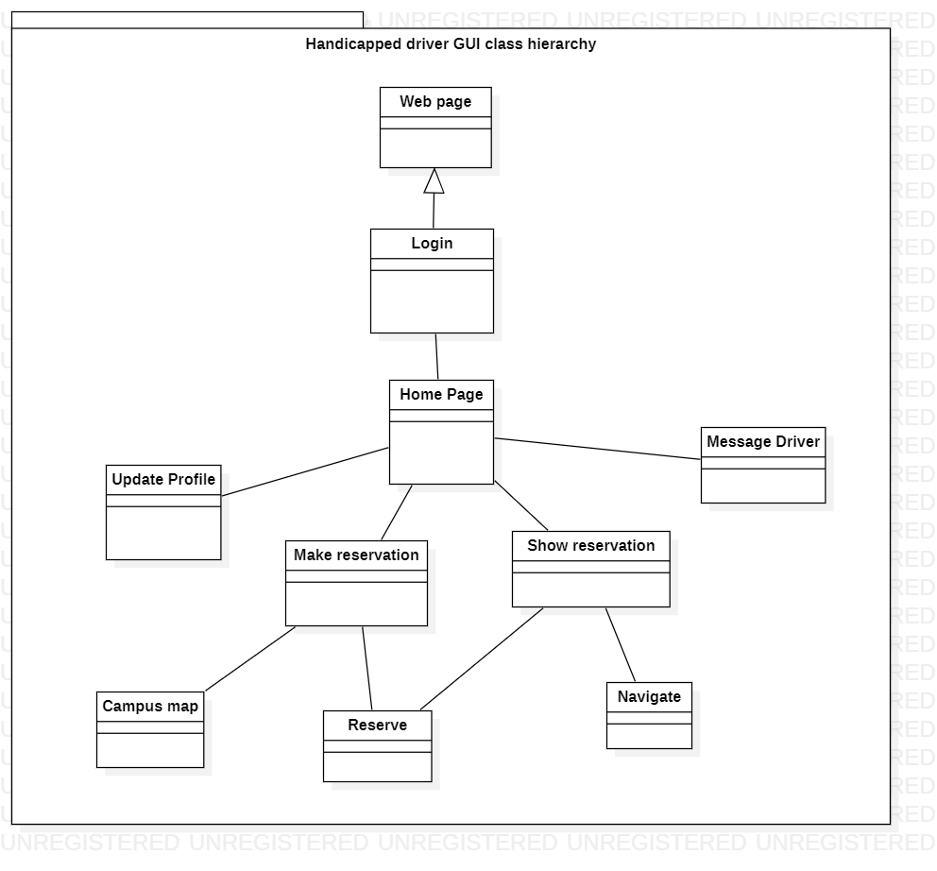
The package diagram above represents the navigation path of the user interface. Initially, when the user login, the page directs to the home page. In the home page, the user has four options, they are update profile, make reservation, show reservation, and message driver. The make reservation page has two GUI, campus map and reserve spot. By clicking “Reserve” in make reservation page, the user will be taken to show reservation page. The user can also reach the show reservation page by clicking “My reservation” button from the home page. The show reservation page allows the user “Navigate” to their reserved spot and mark that spot as “Occupy”, “Leave” or “Cancel”.

User Interfaces System Requirements

Login

The application starts with the login page (screen shot of login page can be seen in appendix B “picture 8.1.1.1”). The user will enter his/her user name for validation purposes and click the “LOGIN” button to proceed to the home page.

Requirements
The user does not have to enter their full UCO email extension. The text field already has the extension to its right. If the user does not exist in the system, the system will generate a temporary password and an email will be send to the user specified address.

Home page
After the user successfully login, the user will be taken to the home page (displayed in the appendix B “picture 8.1.1.2”). Here the user has four options to choose from.

Requirements
As mentioned in the requirements for login page, first time users will receive a temporary password via email. The user cannot experience the full capability of the system without resetting his/her password. Every button will be disabled except the “Update profile”. This is to make sure that the user has entered all the necessary information.

Update profile
The user can update their profile by clicking the Update profile button in the homepage. Here the user will be prompted for some inputs. (screen shot in appendix B “picture 8.1.1.3”)

Requirements

It is necessary to fill out all the fields in this page.

View available
This page allows the user to do the following actions:
- View campus map
Here the user can view the campus map by clicking “Campus map” button in the view available page. The user will be taken to a page owned by UCO, which displays an image of the entire campus in .pdf format (Reference can be found under section 8.1.2 appendix B “ref 8.1.2.1”).
- Make reservation
Here the user can reserve their spot by clicking “Reserve spot” button.

Requirements:
The user must select a lot from the dropdown next to “Reserve spot” button. Otherwise, a spot won’t be reserved, and nothing will be saved to the database.
Note: - Screenshot of this page can be seen in appendix B “picture 8.1.1.4”.

Show reservation
Once the user clicks the “Reserve spot button in View available page”, they will be directed to the show reservation page. Here the user can navigate to the spot by clicking “Navigate” which will open google maps in another page with the specified location. After the use has reached their destination the user can mark the spot as “Occupy”. When the user decides to leave, he/she can click “Leave” button to free that spot. Also, if the user decided to change his/her mind and want to cancel the reservation, they can do that by clicking “Cancel” button. (Screenshot in appendix B “picture 8.1.1.5”)
If the user wishes to go to the “Show reservation” directly from the home page, the user can do that by clicking “My reservation” button in the “Home page”. (appendix B “picture 8.1.1.2)

Requirements
This page uses Google maps API version 3.36 or above. (Reference: “ref 8.1.2.2”)

Message Driver
The system has a capability to message another, who is parked in someone else’s spot. The user can do this by clicking “Message driver” button in the home page. Here the user will select the vehicle’s registration state from a dropdown and enter the registration number. The system will generate a message and send it to the driver. (Screenshot in appendix B “picture 8.1.1.6”)

Requirements
In order to message a driver that driver must exist in the database.

Requirements Traceability Matrix
<Provide reference to the location of the Requirements Traceability Matrix that indicates traceability from the software requirements document to the design elements documented.>

Appendices
.

